**Why Do We Analyze Blog Performance**

Writing a successful business blog post does not end when you hit “Publish”. A few weeks ago, we discussed how to draft an [effective business blog](http://www.virtualstacks.com/how-to-write-a-business-blog/), now let’s explore why it is important to analyze that blog’s performance. How can you know its level of success without analyzing its performance? The style and necessity of writing a business blog vary with the organization, but the reasons behind its inception are relatively the same. Gaining exposure, attracting target markets, and creating traffic to your website result in a higher conversion rate. A truly successful blog post will intrigue your target audience enough to draw them in; hopefully transforming them into leads and eventually customers.

Calculate Your **Conversions**

Content marketing is only as effective as the conversion rate and the revenue generation prove it to be. Counting your conversions is the most significant aspect to analyzing the success of your blog. Target audiences finding value in the blog content will be what turns consumers into customers. The conversion rate calculates the number of readers taking tangible steps while visiting the page. Tracking steps like:

* Downloads
* Sign-ups/Subscribers
* Actual Purchases

Any consumer engagement, especially surrounding specific content, should be added into the calculation of conversions.

Keep track of **Traffic** patterns

The slightest site renovation can be an improvement or downgrade to your site’s traffic. Anytime changes are made, whether formatting or content focal points, monitor your readership numbers for any relative changes. Online readers have notoriously short attention spans and are quite picky. A post’s content must hold a certain quality and significance that keeps readers interested in what your organization has to say and essentially offer. Your target audience will not only continue to return to your blog, but will also increase your views by referring you to others within their networks.

How **Social** is it?

Your online presence reflects your market standing so the greater the social activity of your blog, the greater the number of readers and potential clientele. The amount and frequency of social shares to your blog from the like-minded writers to the interested readers will measure your content’s value. Word of mouth (or in this case word of click) is the oldest and most effective marketing your blog’s traffic can do for your business.

* You should be on the giving and receiving end of your Search Marketing Integration (SMI) strategy. Keep up the interaction and exchange by returning the favor with articles you enjoy.

**Leads** lead to converts

Is your blog generating quality leads? A successful business blog will act as a strong marketing tool for your company. The best course of action is to tailor your content to draw the focus of your target audience. Moving forward, throughout posts and developing consumer interaction, whittle content into more valuable topics to those potential converts.

* Monitoring the number of visits to the page, even those bounce-backs that don’t stay on the page long, becomes beneficial data to your analysis.

Evaluate your **team effectiveness**

A ship is only as sea worthy as the crew manning it. It is important to hold your content writers, marketing & sales teams and anyone else involved in blog maintenance accountable for the strength of your blog. Your blog depends on their productivity and you should measure the value in each writer’s performance. Is their work advancing traffic? Are they producing creative content that not only brings in leads, but translates them into revenue? This will also help amplify their strengths and reduce weaknesses.

The use of website analytics programs designed to record and report the performance data for easier metrics management is the best way to stay ahead of your competition. Mentionable Website & Blog Analytics products include:

* [Page Performance](http://knowledge.hubspot.com/page-performance-user-guide/how-to-analyze-blog-posts-in-page-performance)
* [Google Analytics](http://www.google.com/analytics/)
* [KissMetrics](https://kissmetrics.com/)

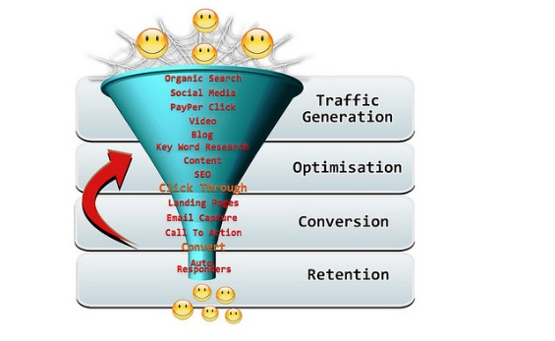

Photo Courtesy of [Laurie Caradonna](https://www.flickr.com/photos/creativedreamstudio/4834105278)